# Specification for modules on NAROM student rockets

Revision date: 01.02.2016

NAROM student rockets has both analog and digital interfaces and strict physical dimensions of the sensor boards. All connectors are of the Micronector type to withstand the large forces acting on the rocket during flight. All designs should be given a “go” from NAROM prior to arrival at Andøya Space Center.

## Flight characteristics

* Expected height: 9 km
* Flight time: 90 s
* Spin: Up to 25 Hz
* Acceleration: Less than 30 g axial direction
* Coning is an effect, but usually negligible regards to forces working on the body.

## Telemetry format

* Full frame rate
* Figure 3 shows the 8-bit words of the telemetry format. Two 8-bit sync words (0xEB90) is followed by a 16-bit frame counter, then the 8 analog channels and 2 digital channels at the end. 14 bytes in total.
* 250 kbps data rate
* Sensor sampling rate = 250 kbps / 14 bytes / 8 bits = 2232 Hz

## Analog interface

* Single-ended measurements
* Voltage range: 0-5V
* Four pins: pin 1 is 5V voltage source for the sensor, pin 2 and 3 are ground and should be twisted around each of the other wires, and pin 4 is the analog signal.
* 8-bit resolution
* Has a 1kHz Sallen-Key low-pass filter (could be disabled on request by NAROM)
* Usually NAROM uses all eight analog channels to a fixed sensor pack (as can be seen in Figure 3). If an analog channel is needed, ask NAROM to multiplex analog sensors leaving one analog channel unused.

## Digital interface

* The interface is 8-bit parallel
* Voltage range: 0-5V
* See the table below for pin definition. Figure 1 gives the pin numbering definition. Note that the digital input has 14 pins, not 8.
* Pin 14 on each digital ports is driven low on umbilical release (lift-off)
* All 8 bit pins has weak 100k pull-ups
* A 64us pulse on pin 5 and 6 indicate the start of frame. The digital interfaces is sampled 64us after the pulse has been driven low again. This is used to know when to sample the measurement and have data ready for the encoder.

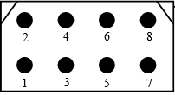

Figure 1: Pin numbering definition of the student rocket. All connectors are Micronectors. Note that the digital interface consist of two 14-pins Micronectors. Pin description is seen below.

|  |  |  |
| --- | --- | --- |
| **Pin number** | **Name** | **Description** |
| 1. | 5V | 5V voltage source for driving the sensors. Maximum 50mA |
| 2. | 5V | 5V voltage source for driving the sensors. Maximum 50mA |
| 3. | GND | Ground |
| 4. | GND | Ground |
| 5. | FrameStart | Digital output to indicate start of frame |
| 6. | FrameStart | Digital output to indicate start of frame |
| 7. | D0 | Digital in. Bit 0 (LSB). |
| 8. | D1 | Digital in. Bit 1. |
| 9. | D2 | Digital in. Bit 2. |
| 10. | D3 | Digital in. Bit 3. |
| 11. | D4 | Digital in. Bit 4. |
| 12. | D5 | Digital in. Bit 5. |
| 13. | D6 | Digital in. Bit 6. |
| 14. | D7 | Digital in. Bit 7 (MSB). |

## Physical size

* There are pre-drilled holes for the sensors in the payload plate which is centered along the rocket travelling direction. All pre-drilled holes are of size M3.
* See Figure 2 for the physical dimensions. All dimensions are in millimeters.
* The sensor cards should be 50 mm wide and 31 mm in height. The *red* circles gives the position of the holes to be used for the sensor PCB and they are centered on the payload section plate.
* If needed and allowed by NAROM (since the rocket configuration for the flight is Mongoose 98), the sensor PCB width can be extended from 50 mm up to 90 mm.
* In extreme cases the sensor board need to be extended in height. If given permission by NAROM, the sensor board can extend to the neighboring sensor board slot. The distance to the next pre-drilled hole set on the sensor plate is given in blue in Figure 2.

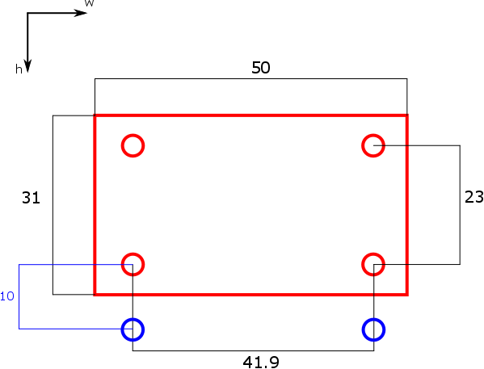

Figure 2: Physical dimensions of each student rocket sensor board. Red gives dimensions of the board, and blue gives the location of the holes for the next board. All sizes are in millimeters

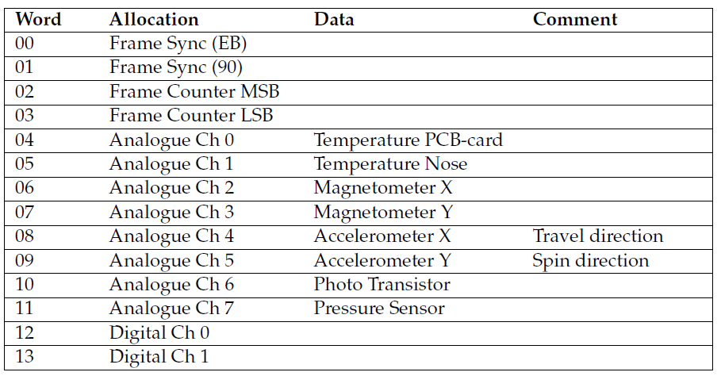

Figure 3: Word allocations of the PCM format in the student rocket